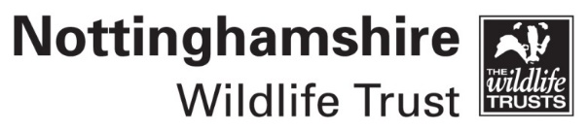
Click here to apply online

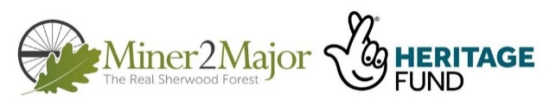
Volunteer role description

Role title: Young Ranger (open to 13-18 yrs.)

Team/Group: Keeping it Wild/ People and Wildlife

Your volunteer leader: Jamie Shortland

Volunteering base: Various sites around Mansfield and Sherwood

Why we need this role

Young people are vitally important to the Nottinghamshire Wildlife Trust’s mission to protect wildlife and to enhance habitats and the environment. We are passionate about offering exciting and valuable opportunities for young people, enabling them to make a positive difference through practical activities and learn new skills by meeting and working alongside our team and staff.

This role sits within the Miner2Major (M2M) Sherwood Landscape Partnership Scheme, which is a 5-year National Lottery Heritage Funded project.

This programme is made up of several different elements, which aim to connect people with the nature and heritage of Sherwood. NWT are delivering one of the projects Key elements known as “Better Habitats” This element of M2M will enhance, restore, re-create and re-link Sherwood’s heathlands and other characteristic habitats, making them more resilient and more favourable for the priority species which they support.
We need volunteers to join us in making Better Habitats a success by helping the team to conserve, enhance and maintain the important habitats across NWT sites and other M2M Partnership sites in the wider Sherwood Area.

We believe young people are our champions now and importantly in the future. Our ‘Young Ranger’ youth volunteering project offers a fantastic opportunity to engage with our wildlife work, inspiring Nottinghamshire Wildlife Trust with new ideas and taking part in our work with passion and energy.

What this role involves

As a member of the ‘Young Ranger’ team, this volunteering role for 13 – 18yrs is about active participation.

The Young Ranger teams meet on a monthly basis to carry out a wide variety of activities which can involve helping with wildlife work and monitoring nature, community events and practical conservation,

We meet at various nature reserves around Mansfield and Sherwood – you will be told where to meet in advance of the session. We do almost all of our activity outdoors and we ask young people to be prepared and to dress for the weather. Depending on the activity, we recommend wearing something not too precious (which can get messy), with sturdy footwear or wellies when required.

We provide the tools and personal protective equipment such as gloves to all members of the team

Experience and skills needed

No specialist skills are required we just request our team members to be motivated, passionate and enthusiastic about the environment and wildlife.

New members need to feel able to work as part of a team to help improve the environment and to encourage others to do so and be willing to try new things and learn new skills whilst having great fun too!

Benefits and training opportunities

You will:

- Meet new people and make new friends.
- Have fun and be part of a team that makes a real difference.
- Be able to take part in unique wildlife opportunities with local experts.
- Help protect your local environment in a hands-on way, encouraging more people to care about wildlife in the future.
- Feel more connected to nature, the community and Nottinghamshire Wildlife Trust.
- Represent the trust and help plan events, projects and campaigns.
- Gain valuable experience in many areas that will help you with your future career/learning paths, your personal development and gain valuable life skills.

Commitment

There is no time commitment to being a member we just ask that you come as often as you can. We encourage and support you to consider new opportunities as you reach the upper age limit of the group. New opportunities could be to become a member of the Keeping It Wild youth team.

Duration of role

Ongoing until you reach the upper age limit.

References required? NA

All volunteers are asked to agree to our Volunteer Code of Conduct

If you are under 18yrs we will require parent/guardian consent which is included in the application form

Click her to complete an online application form

www.nottinghmamshirewildlife.org/get-involved

