Nottinghamshire
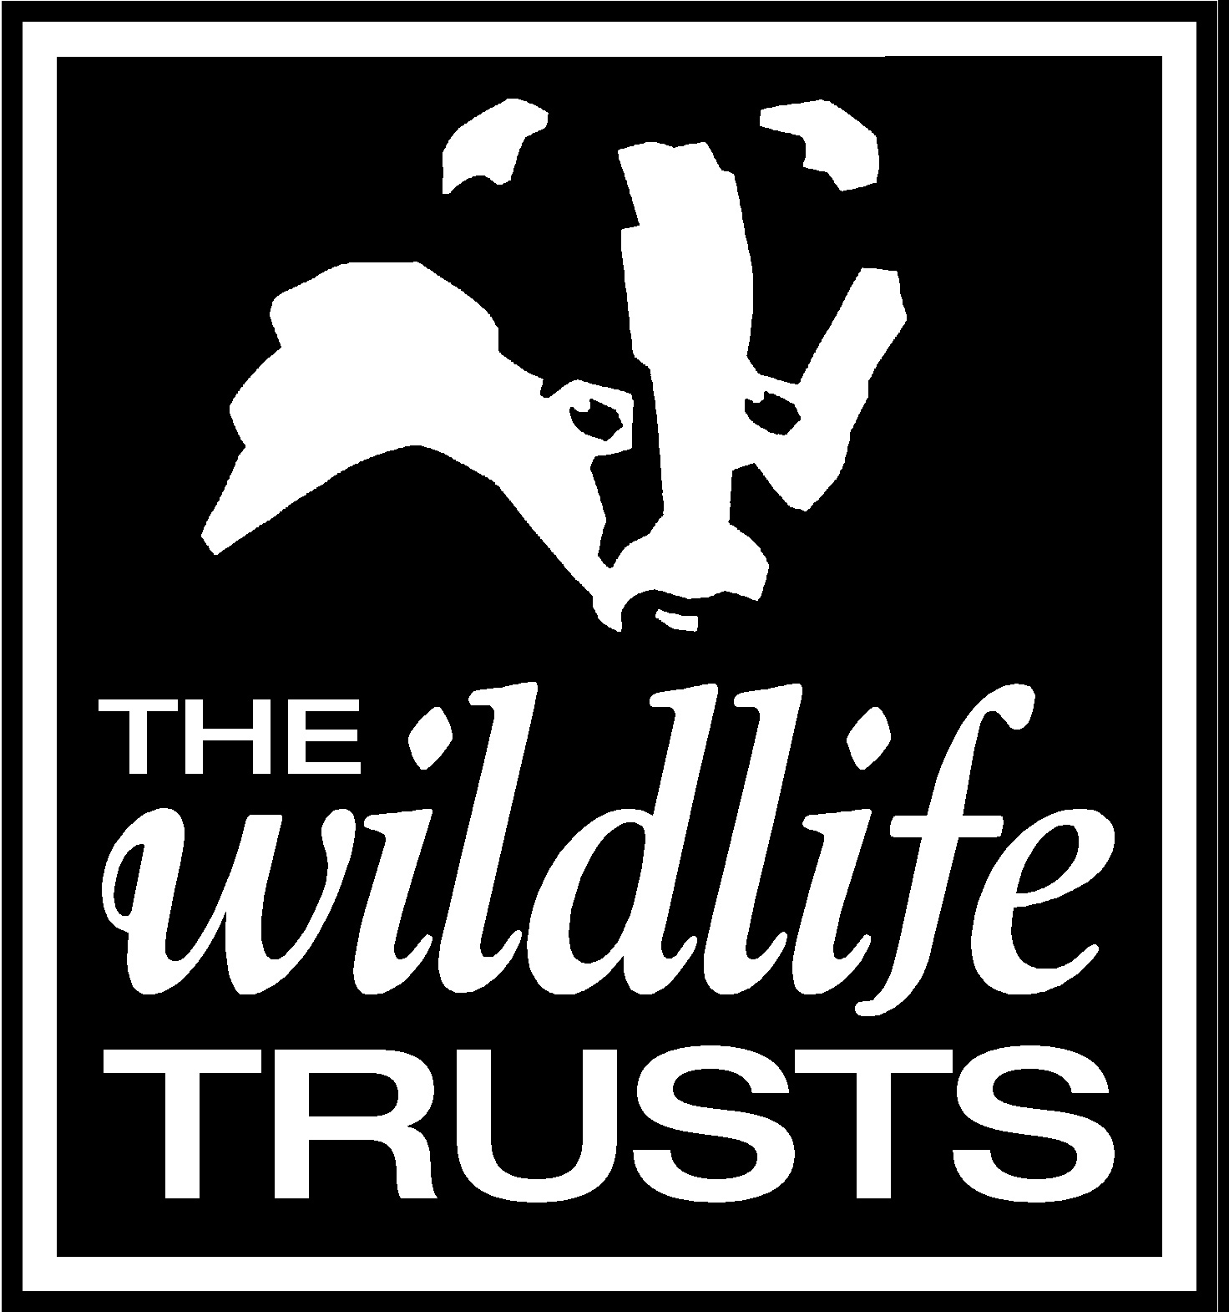
Wildlife Trust
____________________________________________________________________
Candidate No (office use only): ………………………

APPLICATION FORM
POST: WILDLIFE MONITORING CO-ORDINATOR  CLOSING DATE: 8am Monday 3 May 2021  WHERE DID YOU SEE THIS VACANCY ADVERTISED? | PLEASE COMPLETE AND RETURN TO:–  vacancies@nottswt.co.uk  OR:  Senior HR Officer  Nottinghamshire Wildlife Trust  The Old Ragged School  Brook Street  Nottingham  NG1 1EA
- PLEASE COMPLETE IN BLACK PEN OR TYPESCRIPT
- PLEASE DO NOT ATTACH A CV AS IT WILL NOT BE CONSIDERED
- PLEASE ANSWER ALL QUESTIONS AND GIVE AS MUCH DETAIL AS POSSIBLE

PERSONAL DETAILS
SURNAME |  |  | FIRST NAME
ADDRESS

POSTCODE
TELEPHONE | HOME |  | MOBILE
EMAIL

PRESENT OR MOST RECENT EMPLOYMENT
EMPLOYERS NAME, ADDRESS AND POSTCODE

POST HELD
DATES OF EMPLOYMENT
SALARY
REASON FOR LEAVING
PERIOD OF NOTICE REQUIRED
Please give a brief description of the your present/most recent duties and responsibilities:

PREVIOUS EMPLOYMENT
FROM | TO | EMPLOYER | POSITION | REASON FOR LEAVING

EDUCATION AND QUALIFICATIONS including Training Undertaken
DESCRIPTION OF COURSE(S) UNDERTAKEN  (INCLUDING SPECIALIST IN-HOUSE TRAINING, SHORT COURSES ETC) | QUALIFICATIONS OBTAINED | DATE

CRIMINAL RECORD
PLEASE GIVE DETAILS OF ANY UNSPENT CRIMINAL OFFENCES IN ACCORDANCE WITH THE REHABILITATION OF OFFENDERS ACT (EXCEPTIONS) ORDER 1975 AND/OR (NORTHERN IRELAND) 1979.
Nottinghamshire Wildlife Trust fully complies with the Disclosure and Barring Service (DBS) Code of Practice, a copy of which is available on request. If this post is subject to a DBS disclosure, it will be requested in the event of a successful application, but a criminal record will not necessarily be a bar to a successful application.

ADDITIONAL INFORMATION
Before completing this section, please read the enclosed job description and person specification carefully. Use the requirements listed in the person specification as headings (e.g. Area A. Experience; Area B. Competence, Knowledge & Skills, Area C. Personal Qualities, etc.) and demonstrate how you meet the requirements by giving relevant details of your experience, skills and knowledge gained in employment or elsewhere. (Continue on back page and attach one additional sheet if necessary.)
Please continue onto additional sheets as required

DATA PROTECTION STATEMENT
If you succeed in your application for employment, the information will be used in the administration of your employment with us and will be kept in line with our data retention policy. If you application is unsuccessful your details will be held on file for six months.
We may check the information collected with third parties or with any other information held by us. We may also use or pass to third parties, information to prevent or detect crime, to protect public funds, or in other ways as permitted by law. For further information on how we process your data please see our privacy policy.

DECLARATION
I declare to the best of my knowledge all information I have given on this application form are complete and true. I understand that any false declaration, misleading statement or a significant omission may disqualify me from employment. If I am not successful in my application, I understand that my application will be retained for six months.

Please sign to confirm your acknowledgement of and agreement with the Data Protection Statement and Declaration above.
SIGNATURE |  | DATE

